ỦY BAN NHÂN DÂN TP.HCM CỘNG HÒA XÃ HỘI CHỦ NGHĨA VIỆT NAM
TRƯỜNG CAO ĐẲNG LÝ TỰ TRỌNG TPHCM Độc lập – Tự do – Hạnh phúc
********** ******
PHIẾU TRẢ LỜI TRẮC NGHIỆM
Tên: ____________________________________ Đề thi số: 01
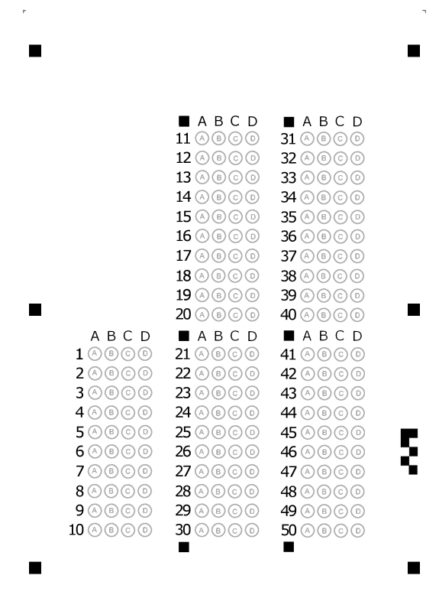
Lớp: ___________ Ngày thi: _____________

ỦY BAN NHÂN DÂN TP.HCM CỘNG HÒA XÃ HỘI CHỦ NGHĨA VIỆT NAM
TRƯỜNG CAO ĐẲNG LÝ TỰ TRỌNG TPHCM Độc lập – Tự do – Hạnh phúc
********** ******
ĐỀ 1
ĐỀ THI GIỮA HỌC PHẦN LÝ THUYẾT
BẬC ĐÀO TẠO : CAO ĐẲNG
HỌC PHẦN : ANH VĂN
HỌC KỲ : II NĂM HỌC: 2017 - 2018
Lớp: ___________________ Ngày thi: ______________/ 2018
Thời gian thi : 60 phút
(Sinh viên không được sử dụng tài liệu trong khi làm bài. Sinh viên trả lời vào PHIẾU TRẢ LỜI TRẮC NGHIỆM)
(Đề thi gồm 50 câu. Mỗi câu trả lời đúng được 0.2 điểm)
------------------------------------------------
A. LISTENING
Part I: Listen to the short talk and then fill a word in each blank. Choose the best answer. (CD1_1.26)
My name’s Jenny Zielinski. I live and work in New York. I’m the assistant editor of a magazine called New York 24seven. A few months ago, I visiting our (1) ____________ in London to learn more about the company. I met the manager, Daniel O’Connor. I had lots of (2)___________ with him, of course. And a working dinner on my (3)___________.... But I spend more time with Rob Walker. He’s one of the (4) ____________ on the London magazine. We had coffees together. We went sightseeing. I ever helped Rob buy a shirt! He was fun to be with. I liked him a lot. I think he liked me, too. Rob isn’t a punctual person in the world, but he is a great writer. We (5)__________ him to work for the New York magazine for a month… and he agreed! So now Rob’s coming to New York. I know he’s really excited about it. It’s going to be great to see him again.
- A. house B. home C. office D. hometown
- A. meet B. meetings C. visit D. visitor
- A. birthday B. vacation C. holiday D. visit
- A. teachers B. journalists C. students D. writers
- A. invited B. worked C. want D. ask
B. READING
Part II: Incomplete Sentences: Choose the word or phrase that best complete the sentence.
- Where do you ….. from?
A. come B. coming C. comes D. came
- Where ….. the train station?
A. are B. were C. is D. have
- How often ….. you read magazines?
A. did B. was C. do D. does
- Where ….. your friends from?
A. is B. are C. does D. do
- Why …. you write to me?
A. was B. were C. does D. didn’t
- Do you often …. to the movies?
A. go B. goes C. went D. gone
- What does ….. mean?
A. word B. this word C. words D. these words
- What time did your friends ….?
A. arrive B. arrives C. arrived D. arriving
- Where were you….?
A. borning B. borned C. bornt D. born
- you a do have car ? _________________________
A. You have a car? B. A car you have? C. Have you a car? D. Do you have a car?
- What ….were you born? - 1983
A. year B. day C. time D. date
- ……do you live ? - Rome
A. who B. where C. how D. Which
- ……. any brothers or sisters?
A. Have you B. Do you C. Do you have D. Does you have
- ………..last night?
A. Where you went B. Where did you go C. Where you did go D. Where went you
- My brother …… soccer.
A. doesn’t like B. don’t like C. doesn’t likes D. don’t likes
- His parents …… a small business.
A. has B. haves C. have D. does have
- I…….. to music when I’m working.
A. never listen B. don’t never listen C. listen never D. never listens
- In the picture the woman __________ a blue dress.
A. wears B. wearing C. are wearing D. is wearing
- A: What ________? B: I’m looking for my keys.
A. you are doing B. do you do C. do you do D. are you doing
- She is in college. She ______ engineering.
A. ‘s studing B. ‘s studying C. studying D. ‘re studying
Read adverts and choose a holiday which is convenient for you.
ANTARCTICA  Do you like nature? Do you like the cold? If so, then this is the holiday for you! Spend 10 or 15 days at the South Pole walking, fishing, and watching penguins. | BERMUDA  Spend 7 or 10 nights on this fantastic Caribbean island which is ideal for families and couples. If you like doing nothing except sunbathing, swimming in the turquoise sea, and drinking exotic cocktails, then choose this holiday!
AUSTRALIA  Is it possible to see Australia in less than a month? Yes, it is! Come with us and see the best of Australia’s beaches, rainforests, and cities. Tours last two or three weeks. Our friendly guides will take you to all the best places and make sure you have a fantastic time. | ITALY  If you like cooking and culture, read more! Stay in Florence and learn how to cook fantastic Italian dishes. English speaking teachers and very small groups. Prices all include in ingredients, tuition, and an evening meal cooked by the course participants. Courses last three or six days.

- You can speak English well and like cooking very much. Next week you will have a week off. Where are you going to on your vacation?
A. Australia B. Italy C. Bermuda D. Antarctica
- You love nature, especially penguins. You want to see them. Where are you going to?
A. Australia B. Italy C. Bermuda D. Antarctica
- You are going to have a wonderful holiday with your family for a week. Where are you going to?
A. Australia B. Italy C. Bermuda D. Antarctica
- On your vacation, you want to go sightseeing in cities, sunbathe on beautiful beaches, and visit rainforests. Where are you going to?
A. Australia B. Italy C. Bermuda D. Antarctica
- They found the money ________ I dropped.
A. who B. whom C. whose D. that
- The police arrested the man ________ I saw steal a handbag.
A. who B. which C. whose D. that
- She wrote to her friend ________ lives in Vietnam.
A. whom B. which C. where D. who
- Stop worrying ______ your exam – everything will be fine.
A. about B. in C. on D. at
- I’ve waited ______ Judy for 30 minutes. I’m going home.
A. at B. in C. of D. for
- I don’t know what we’ll do at the weekend. It depends ______ the weather.
A. in B. on C. for D. about
- She will arrive ______ Beijing at 3p.m.
A. for B. about C. in D. at
- You're always asking me ______ some change. Can't you ask someone else this time?
A. for B. to C. on D. about
- I have been waiting for you _____
A. since early morning B. since 9 a.m
C. for two hours D. all are correct
- Look! The bus _____.
A. left B. has left C. is leaving D. leaves
- Jane and I _______ school in 1989
A. finish B. have finished C. finishes D. finished
The image that cost a fortune
Caroline de Bendern was born in 1940. She (41)__________ the granddaughter of Count Maurice de Bendern, a rich aristocrat who owned a lot of property (42)_______Paris and Manaco. Although he had other grandchildren, the Count decided to (43) _________ all his money to Caroline. “I never knew why,” says Caroline. “Perhaps because I was (44)_________.” He paid (45) _______ her to go to very expensive schools in England, and he (46) _______ that she would marry well, perhaps a member of a European royal (47) _________ . But Caroline was a rebel. She (48) ______ to New York and worked there for a short time as a model. (49)______, in 1968 she was 28 ___________(50), she returned to Paris…
- A. is B. was C. isn’t D. wasn’t
- A. in B. on C. at D. under
- A. left B. leaving C. leave D. leaf
- A. ugly B. unkind C. cheap D. pretty
- A. in B. on C. at D. for
- A. hope B. to hope C. hoped D. hoping
- A. family B. families C. famous D. fame
- A. to go B. go C. went D. gone
- A. Then B. After C. So D. Such
- A. year B. year old C. years old D. year-old
------The end-----
TRƯỞNG KHOA GIẢNG VIÊN RA ĐỀ

Trần Kim Thu Liễu Nguyễn Thị Thanh Tú

